Room Allocation and Scheduling _____Management System______

UCS310 - Database Management Systems

B. Tech (2nd Year) – COE
2025


Submitted By:
Abhilakshya Puri (1024030445)
Aryan Gupta (1024030455)

Submitted To:
Dr.Cheenu

Department of Computer Science & Engineering

Thapar Institute of Engineering & Technology (Deemed-to-be-University)
Patiala-147004, Punjab, India

2025-2026

INDEX

- INTRODUCTION

- PROBLEM STATEMENT
- OBJECTIVES OF THE PROJECT
- SCOPE OF THE PROJECT
- PROPOSED SYSTEM DESCRIPTION
- DATABASE DESIGN
- NORMALIZATION
- DATABASE IMPLEMENTATION

- TRANSACTION MANAGEMENT & CONCURRENCY
- TOOLS & TECHNOLOGIES USED
- EXPECTED OUTCOMES

INTRODUCTION

The Room Allocation and Scheduling Management System is designed to solve daily room management challenges in a college. It provides a centralized database where students, faculty, and societies can check which room is assigned to which class, event, or activity with exact timings.
The motivation for this project comes from frequent confusion in manual scheduling through notices and spreadsheets. During busy academic and event periods, multiple teams may request the same room, causing clashes, delay, and last-minute adjustments.

The system uses a Database Management System (DBMS) instead of file-based records to ensure structured storage, faster retrieval, secure multi-user access, and reliable update control. It provides better scalability, consistency, and operational transparency.

PROBLEM STATEMENT

Room allocation in many institutions is managed manually, making it difficult to track real-time availability. Without a centralized system, classes and events can be assigned overlapping rooms for the same slot, resulting in operational conflict and poor coordination.

Manual records also limit accountability because request approval history is scattered and difficult to audit. Identifying who approved, rejected, or modified a booking becomes time-consuming and error-prone.

A DBMS-based solution addresses these issues by storing room master data, slot schedules, requests, approvals, and logs in linked relational tables. Constraints and controlled transactions prevent conflicts and maintain consistent data.

OBJECTIVES OF THE PROJECT

- To design a proper database for the Room Allocation and Scheduling Management System using E-R data modelling.
- To convert the ER model into relational tables with suitable primary keys and foreign keys.
- To implement the database using SQL commands for creating, inserting, updating, and retrieving data.
- To use SQL stored program constructs such as procedures, functions, triggers, and cursors to automate request and allotment operations.
- To ensure data consistency, accuracy, and security by using constraints and transaction management.

SCOPE OF THE PROJECT

FUNCTIONAL BOUNDARIES OF PROJECT
This project will:
  - Manage room master data (classrooms, labs, seminar halls, capacity, and type).
  - Store class/event room allocations with date and time slots.
  - Display room availability (free/occupied) for a selected day and timing.
  - Allow societies/faculty to place room allotment requests.
  - Support request approval/rejection workflow with remarks and timestamps.
  - Generate reports (daily schedule, room utilization, pending requests).
The system will not include:
  - Physical access control hardware implementation.
  - Real-time IoT sensor integration as a mandatory component.
  - GPS-based movement tracking features.

TYPES OF USERS INVOLVED
Admin:
  - Add/remove rooms and time-slot masters
  - Manage users and access rights
  - Approve critical room requests and view analytics
  - Maintain policy rules for room allocation

Timetable/Academic Staff:
  - Record and update class schedules
  - Validate departmental room allocation entries
  - Coordinate timetable-level conflict resolution
Society/Faculty Requester:
  - Check room availability
  - Submit room request for events/activities
  - Track approval status and remarks
  - View request history

PROPOSED SYSTEM DESCRIPTION

The proposed Room Allocation and Scheduling Management System maintains all room-related operations in one centralized database. The system stores details of rooms, time slots, official class schedules, event requests, approval decisions, and final allotments. When a request is raised, availability is checked against existing allocations before any decision is recorded.
If the room is available, the request is approved and an allocation entry is created; otherwise, it is rejected with reason. The system also maintains approval logs so every action remains traceable for audit and governance purposes.
This database-driven approach improves efficiency by reducing manual coordination and repeated communication. It ensures consistency through normalized tables and constraints, while triggers and transaction handling maintain integrity and prevent conflicting bookings.

DATABASE DESIGN

The database of the Room Allocation and Scheduling Management System is designed to store and manage all scheduling and request data in a structured form. Proper design reduces duplication, improves query performance, and supports accurate decision-making.

  - ENTITY-RELATIONSHIP (ER) DIAGRAM
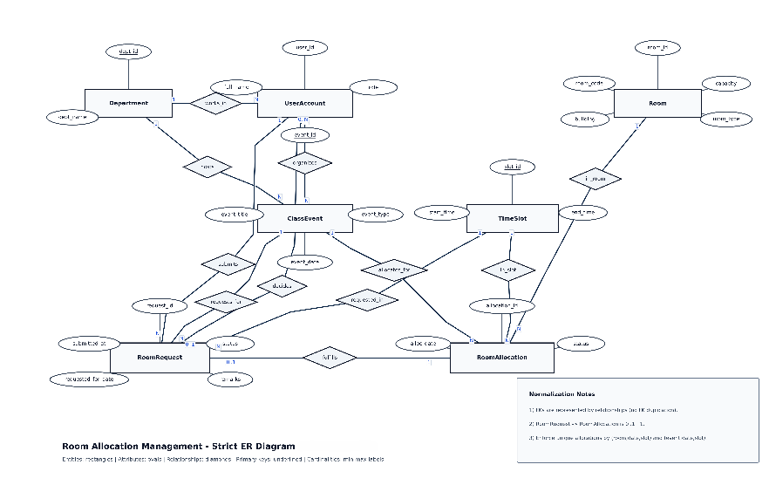

  - Relational Schema

    - DEPARTMENT (dept_id, dept_name) PK: dept_id
    - ROOM (room_id, room_code, building, capacity, room_type) PK: room_id
FK: --

    - TIME_SLOT (slot_id, label, start_time, end_time) PK: slot_id
    - USER_ACCOUNT (user_id, full_name, email, password_hash, role, dept_id, created_at) PK: user_id
FK: DEPARTMENT(dept_id)
    - CLASS_EVENT (event_id, event_title, event_type, organizer_id, dept_id)
PK: event_id
FK: USER_ACCOUNT(user_id), DEPARTMENT(dept_id)
    - ROOM_REQUEST (request_id, requester_id, event_id, room_id, request_date, slot_id, status, decided_by, remarks, created_at, updated_at) PK: request_id
FK: USER_ACCOUNT(user_id), CLASS_EVENT(event_id), ROOM(room_id), TIME_SLOT(slot_id)
    - ROOM_ALLOCATION (allocation_id, room_id, event_id, alloc_date, slot_id, status, created_at) PK: allocation_id
FK: ROOM(room_id), CLASS_EVENT(event_id), TIME_SLOT(slot_id)
APPROVAL_LOG (log_id, request_id, action, action_by, action_time, comments) PK: log_id
FK: ROOM_REQUEST(request_id), USER_ACCOUNT(user_id)

NORMALIZATION

Normalization organizes data to reduce redundancy and improve consistency. In this project, it ensures an efficient and well-structured room scheduling database.

  - Functional Dependencies
Some important functional dependencies in the system are:
    - room_id -> room_code, building, capacity, room_type
    - slot_id -> label, start_time, end_time
    - event_id -> event_title, event_type, organizer_id, dept_id
    - user_id -> full_name, email, password_hash, role, dept_id, created_at
    - request_id -> requester_id, event_id, room_id, request_date, slot_id, status, decided_by, remarks, created_at, updated_at
    - allocation_id -> room_id, event_id, alloc_date, slot_id, status, created_at
    - log_id -> request_id, action, action_by, action_time, comments
    - dept_id -> dept_name
    - room_code -> room_id
These dependencies help in identifying how attributes depend on primary keys.

  - Final Normalized Structure

Department (dept_id, dept_name), Room (room_id, room_code, building, capacity, room_type), Time_Slot (slot_id, label, start_time, end_time), User_Account (user_id, full_name, email, password_hash, role, dept_id, created_at), Class_Event (event_id, event_title, event_type, organizer_id, dept_id, created_at)
Room_Request (request_id, requester_id, event_id, room_id, request_date, slot_id, status, decided_by, remarks, created_at, updated_at), Room_Allocation (allocation_id, room_id, event_id, alloc_date, slot_id, status, created_at), Approval_Log (log_id, request_id, action, action_by, action_time, comments)

The normalized design removes redundancy, improves performance, and ensures accurate and reliable scheduling operations.

DATABASE IMPLEMENTATION

The Room Allocation and Scheduling Management System database is implemented using SQL to manage data efficiently and automate allocation workflow.

- SQL Implementation

Data Definition Language (DDL)
Used to define or modify the database structure (tables, schema, constraints).

  - CREATE: Creates tables (Department, Room, Time_Slot, User_Account, Class_Event, Room_Request, Room_Allocation, Approval_Log).
  - ALTER: Modifies tables
  - DROP: Deletes tables

Data Manipulation Language (DML)
Used to modify data inside tables.

    - INSERT: Adds new records
    - UPDATE: Modifies records
    - DELETE: Removes records

Data Retrieval (SELECT Queries)
Used to fetch schedule and request data from the database.

    - Joins
    - Subqueries
    - Aggregate Functions: COUNT, SUM, AVG, MAX, MIN
    - GROUP BY and HAVING
    - Views
- SQL Components
SQL automates key operations.
- Stored Procedures - A stored procedure is a named SQL block that performs a task with optional parameters. In this system, procedures submit room requests, approve/reject requests, and create final allocations.
- Functions - A function returns a value and is used in SQL expressions. In this system, functions check room availability and compute utilization metrics for reporting.
- Triggers - A trigger runs automatically on INSERT/UPDATE/DELETE events. Here triggers prevent overlapping room booking and maintain approval audit logs.
- Cursors - A cursor processes multiple rows returned by queries. Cursors are used for pending-request processing and report generation workflows.
- Exception Handling - Exception blocks handle runtime issues such as duplicate requests, invalid IDs, and slot conflicts to avoid uncontrolled failures.

- Data Integrity and Security
Data accuracy and security are ensured using:
- Primary & Foreign Keys
- NOT NULL, UNIQUE, CHECK Constraints
- Role-based User Authentication (User_Account)
- Transaction Control (COMMIT, ROLLBACK)

TRANSACTION MANAGEMENT & CONCURRENCY

- Transactions group multiple database operations into a single unit.
  - COMMIT saves changes permanently
  - ROLLBACK undoes changes on error
  - SAVEPOINT allows partial rollback within a transaction

- ACID properties ensure reliable transactions:
  - Atomicity (all or nothing)
  - Consistency (valid state before & after)
  - Isolation (transactions do not interfere)
  - Durability (committed data is permanent)

- Concurrency control manages multiple users accessing data simultaneously using locks and isolation mechanisms to maintain consistency.

TOOLS AND TECHNOLOGIES USED

  - DBMS: MySQL 8.0
  - Query Language: SQL
  - Programming: SQL stored programs
  - Tool: MySQL Workbench
  - OS: Windows

The DBMS manages centralized room data, while SQL support implementation, automation, and reporting.

EXPECTED OUTCOMES

  - Normalized and efficient room allocation database design
  - Accurate room schedule storage and retrieval
  - Automated request, approval, and conflict prevention workflow
  - Reduced manual errors and allocation clashes
  - Improved consistency, transparency, and data integrity.

